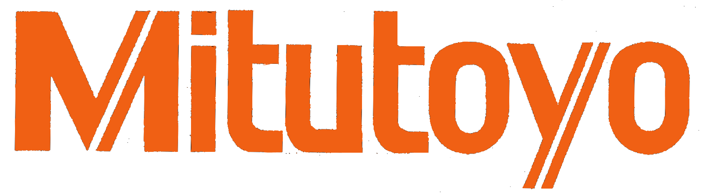
NEWS
Mitutoyo America Corporation
965 Corporate Blvd. • Aurora, IL 60502 Editorial Contact:
phone: (630) 820-9666 • fax: (630) 820-2614 Mark Izumi
www.mitutoyo.com

Mitutoyo America Announces Latest Product in Surface/Form Product Line-up

Countour and surface roughness combined into high-accuracy, contact type CNC measuring system.

(Aurora, IL) – August 18, 2014 – Mitutoyo America has released the new SV-C4500CNC Formtracer Extreme as an addition to its line of Surface/Form Measurement Instruments. This new model combines the versatility of contour and surface roughness functions into a high-accuracy, contact type CNC measuring system. The SV-C4500CNC offers numerous innovative features such as measuring force adjustment via software eliminating the need for physical counter balance weights. The electronic constant force provides stable measurements even when the Alpha-axis in inclined.

Additional feature include; a maximum drive speed of 200mm/sec on all three positioning axes (X1, Y and Z2) for faster set-ups and measurement capabilities resulting in higher throughput; a newly designed contour arm with magnetic mount increasing the Z-axis measuring range and protecting the detector from expensive damage from inadvertent impact; an improved, high accuracy digital arc scale in the Contour detector to ensure robustness and reliability in all environments including in-line processes; and a dual-sided stylus design for analysis of both upward and downward directions without orientation adjustments. A Z2-axis tracking measurement function combined with the dual-sided stylus allows for accurate measurement of large inner and outer diameters while using the column Z2-axis scale positions.

The SV-C4500CNC is powered by Mitutoyo’s FORMTRACEPAK software. FORMTRACEPAK supports easy to create part programing and can generate reports in a variety of customizable formats. The software evaluates a wide variety of surface roughness parameters and conforms to current ISO/JIS/VDA/ANSI standards. A variety of optional product accessories are available to ensure best fit and performance for inspection applications.

(MORE)

Mitutoyo Corporation is the world’s largest provider of measurement and inspection solutions offering the most complete selection of machines, sensors, systems and services with a line encompassing CMMs (Coordinate Measuring Machines), Vision, Form and Surface Finish measuring machines as well as precision tools and instruments, and metrology data management software.

Mitutoyo’s nationwide network of Metrology Centers and support operations provides application, calibration, service, repair and educational programs to ensure that our 6,000+ metrology products will deliver measurement solutions for our customers throughout their lifetime. Contact Mitutoyo America Corporation, 965 Corporate Boulevard, Aurora, IL 60502. Phone: (630) 820-9666 Fax: (630) 820-2614 E-mail: info@mitutoyo.com or visit our website at www.mitutoyo.com # # #

